**1- Introduction to Containers and Docker v1.6**

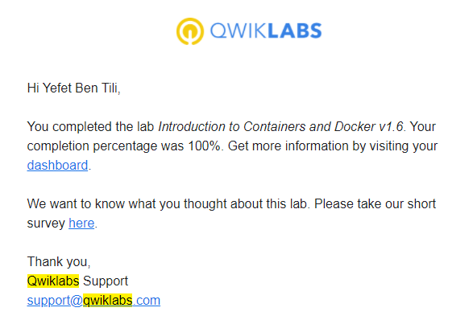

**2- BigQuery Public Dataset**

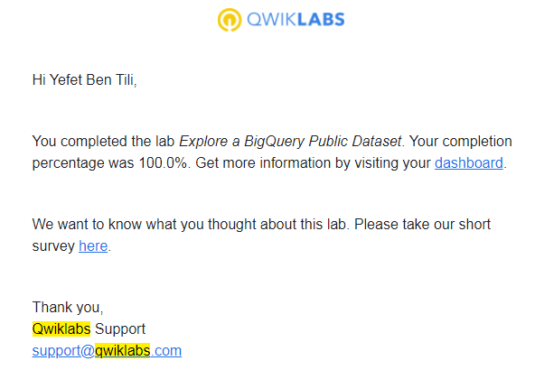

**3- App Dev - Processing Cloud Pub/Sub Data using Cloud Functions**

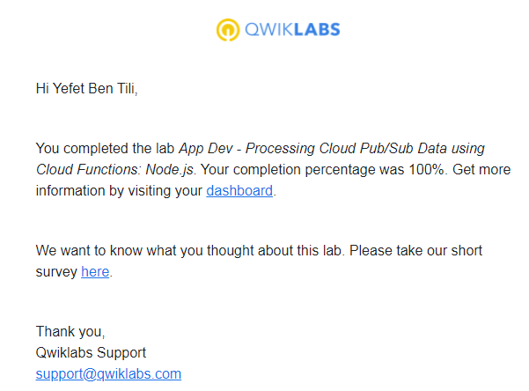

**4- Console and Cloud Shell**

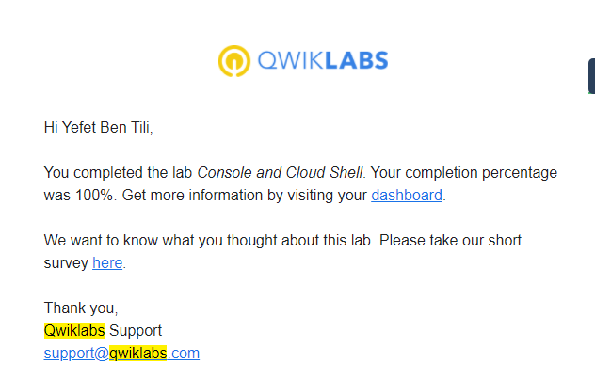

**5- Recommend Products using ML with Cloud SQL and Dataproc**

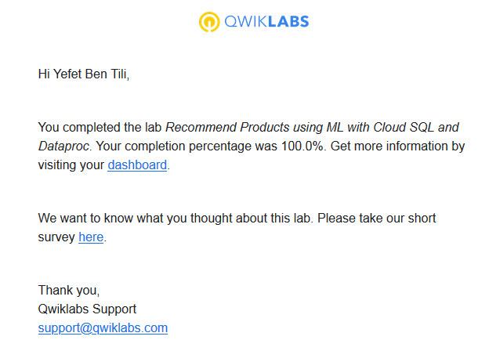

**6-Predict Visitor Purchases with a Classification Model with BigQuery ML**

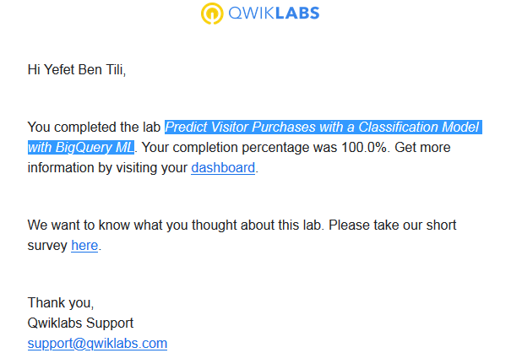

**7-Virtual Private Networks (VPN)**

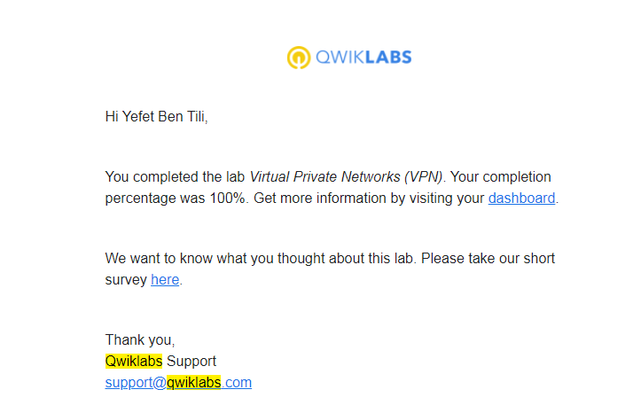

**8-Classifying Images of Clouds in the Cloud with AutoML Vision**

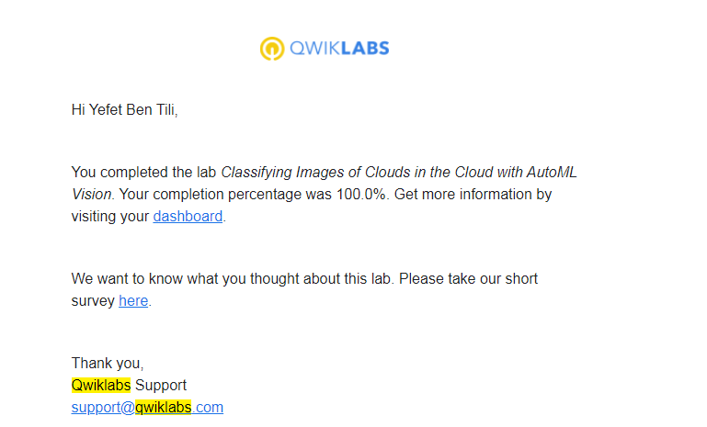

**9-Creating a Streaming Data Pipeline for a Real-Time Dashboard with Dataflow**

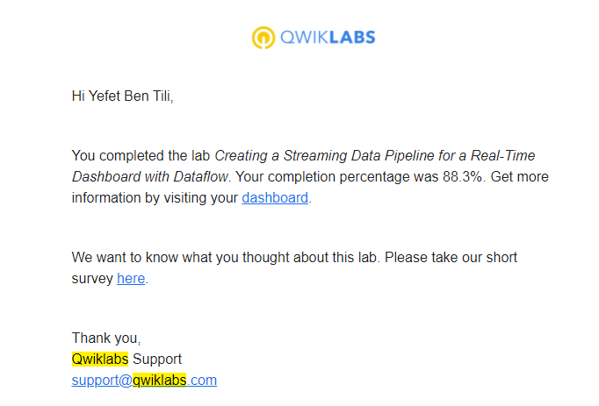

**10-Infrastructure Preview**